|  |  |
| --- | --- |
| EGC_Black | **Mathematics Methods**  **Investigation 1**  **Heron’s Rule** |

**In-Class Validation Total marks: 36 Time allowed: 45 mins**

**NAME** \_\_\_\_\_\_\_\_\_\_\_\_\_\_\_\_\_\_\_\_\_\_\_\_\_\_\_\_\_\_\_\_\_\_\_\_\_\_\_\_\_\_\_\_\_\_\_\_\_

Question 1: [3,3,3 marks]

1. Use Heron’s formula to calculate the area of the scalene triangle shown below.

Show your working and give your answer to 2 decimal places.

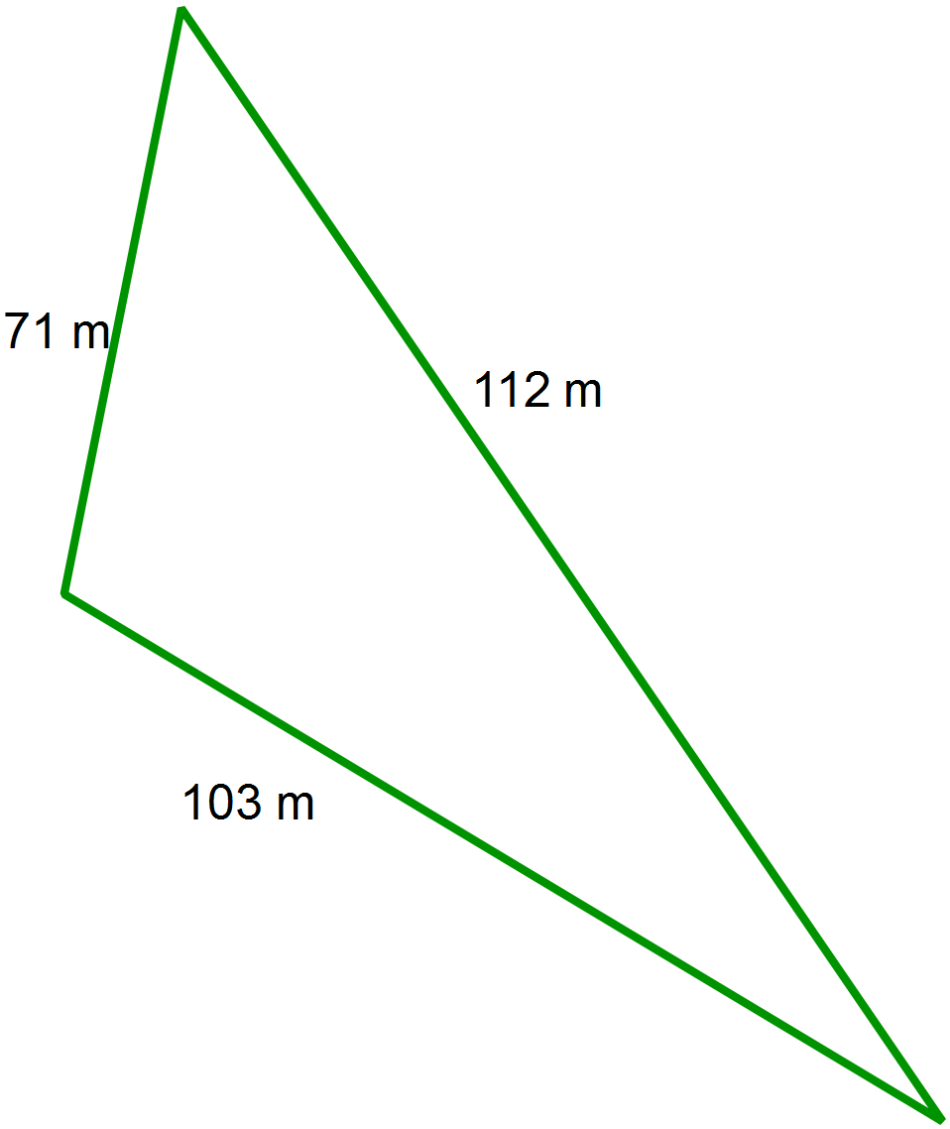

1. Use rules of trigonometry to find the area of the triangle in part (a) and to verify the solution found above. Show clearly the mathematics you used.
2. This equilateral triangle has the *same area* as the triangle from part (a).

Determine the length of the side lengths, accurate to 2 decimal places.

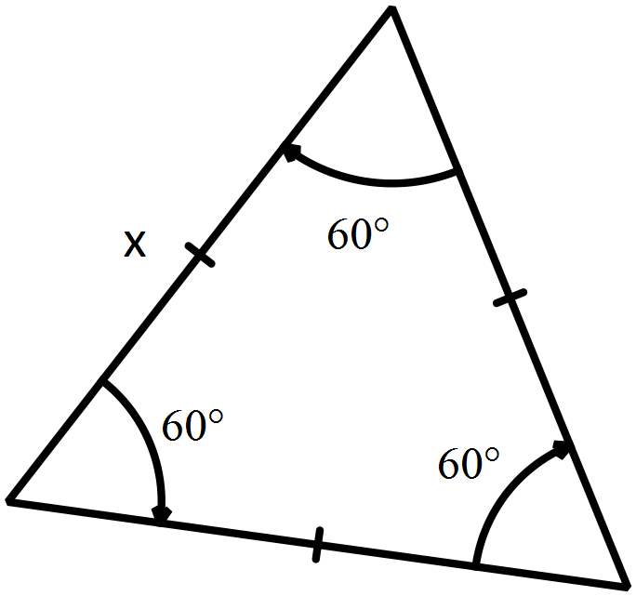

Show working.

Question 2: [1,3,2 marks]

1. Show working to demonstrate that the semi-perimeter, s, of this triangle can be expressed as

s = x + 3.5

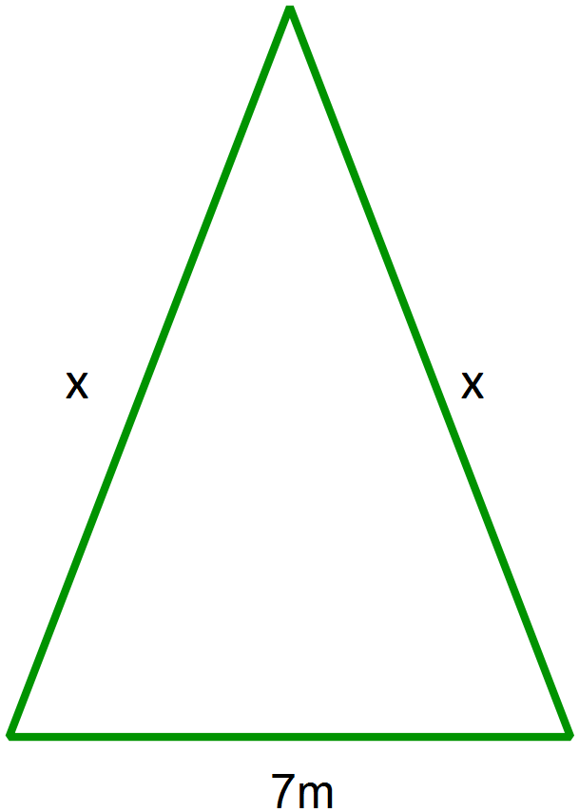

1. Using Heron’s rule, write a simplified algebraic expression for the area of this triangle, in terms of x.
2. Using the Solve function on your ClassPad or otherwise, determine the value of x when the area of the triangle is 25.18m2.

Question 3: [2,1 marks]

1. Use Heron’s rule to find the area of a triangle with sides 6cm, 7cm and 13 cm.
2. Why does this solution occur? You may wish to draw a diagram to assist you.

Question 4: [3,2 marks]

1. Find the maximum area possible for a triangle with a perimeter of 90 cm.

Show clearly how you did this and use a sketch to illustrate your solution.

1. The rule for the maximum area of a triangle with a semi-perimeter of s is equal to .

Show working to verify this rule is correct for the triangle in part (a).

Question 5: [3 marks]

Determine the dimensions of a triangle with an area of 1 hectare (10 000 m2) that has the smallest perimeter. Show how you did this.

Question 6: [1,2,3,2,2]

1. Given the following equilateral triangle, find an expression for s, in terms of a, the side length..

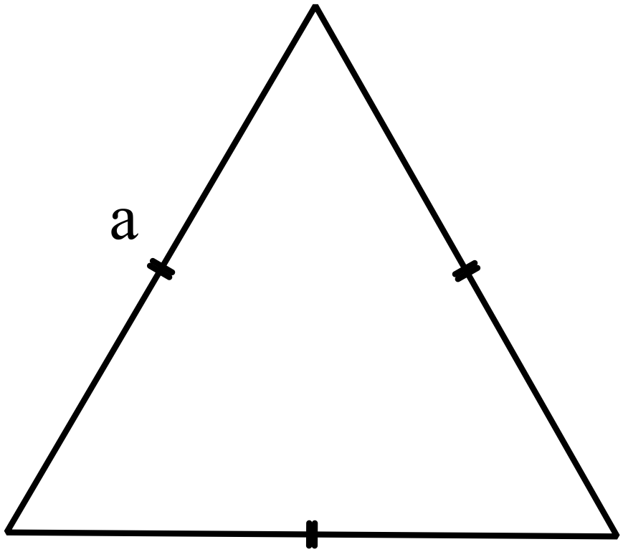

1. Substitute this into Heron’s rule to find an unsimplified expression for area in terms of a.

1. Show algebraic working to demonstrate that A is given by the expression .

1. Investigate what happens to the area of an equilateral triangle when the side lengths are doubled. Show working and conclusions below.
2. Prove your findings above using algebra.

(Hint: Think about doubling the lengths in the triangle in part (a))